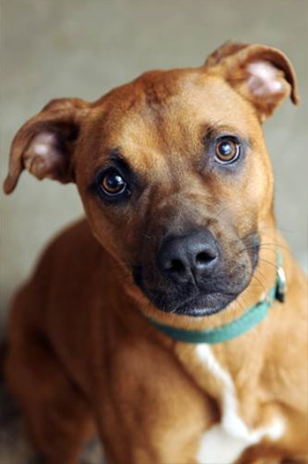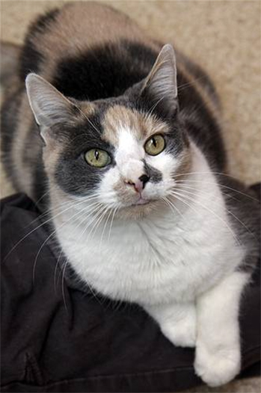

**Adoption Ambassadors** “Business Cards” for Dogs and Cats Template

Pet Photo Here

Pet Photo Here

Pet Photo Here

Pet Photo Here

Pet Photo Here

Pet Photo Here

Pet Photo Here

Pet Photo Here

**Breed – Gender - Age**

Short, two-line description of

dog or cat’s key qualities.

**Your Shelter Name   
or Logo Here**

**Breed – Gender - Age**

Short, two-line description of

dog or cat’s key qualities.

Your Shelter Name   
or Logo Here

**Interested in adopting [name]?**

**Interested in adopting [name]?**

**Call [Name]: 555-555-5555**

**Email: name@address.org**

**Call [Name]: 555-555-5555**

**Email: name@address.org**

**Breed – Gender - Age**

Short, two-line description of

dog or cat’s key qualities.

Your Shelter Name   
or Logo Here

**Breed – Gender - Age**

Short, two-line description of

dog or cat’s key qualities.

**Interested in adopting [name]?**

**Your Shelter Name   
or Logo Here**

**Interested in adopting [name]?**

**Call [Name]: 555-555-5555**

**Email: name@address.org**

**Call [Name]: 555-555-5555**

**Email: name@address.org**

**Call [Name]: 555-555-5555**

**Email: name@address.org**

**Interested in adopting [name]?**

Your Shelter Name   
or Logo Here

**Breed – Gender - Age**

Short, two-line description of

dog or cat’s key qualities.

**Breed – Gender - Age**

Short, two-line description of

dog or cat’s key qualities.

**Your Shelter Name   
or Logo Here**

**Interested in adopting [name]?**

**Call [Name]: 555-555-5555**

**Email: name@address.org**

**Call [Name]: 555-555-5555**

**Email: name@address.org**

**Call [Name]: 555-555-5555**

**Email: name@address.org**

**Interested in adopting [name]?**

**Interested in adopting [name]?**

**Interested in adopting Kobie?**

**American Pit Bull, Male 5YO**

Loves adults, kids and other dogs!

Master at catching a Frisbee.

**Your Shelter Name   
or Logo Here**

**Breed – Gender - Age**

Short, two-line description of

dog or cat’s key qualities.

**Call Allison: 555-555-5555**

Your Shelter Name   
or Logo Here

**Breed – Gender - Age**

Short, two-line description of

dog or cat’s key qualities.

**Call Julie: 555-555-5555**

**Domestic Shorthair, Female 6YO**

Loves to be held and take walks   
with a harness! Likes dogs too.

Home Town  
Animal Shelter

**Interested in adopting Callie?**