Required PPE use
Room/Area:______________________
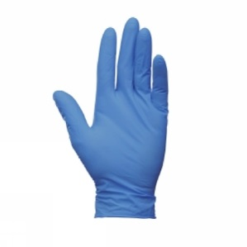
Gloves Required:
Change between cages:
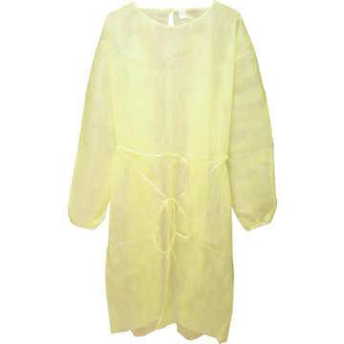

Required: Isolation gowns
Change between cages:
Tyvek Required:
Change between cages:

Required: Booties
Change between cages:
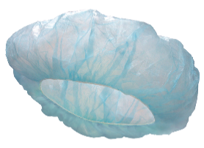

Bouffant Required:
Change between cages:

