Fire Specific Notations

- For searching a specific address, use the find feature (see page 7). This will help you find addresses and information when pet owners or concerned citizens call.

- Abbreviations:
  - HNLT – House No Longer There
  - F/W – Feed and Water
  - F/U – Follow Up
  - SIP – Shelter in Place
  - P/U – Pick Up
  - R/P – Reporting Party
  - LM – Left Message

- If an address or neighborhood is cleared (meaning animal or animal no longer need care), enter N/A in the Recheck column (see column key on page 10). It is important to note in the field notes section of that address the date it was cleared and by who. For example, “9/22 cleared by…”. Owners have returned home and no longer need assistance.” OR, “9/22 cleared. Spoke to owners (note the time they called) and they have advised they no longer need assistance.”

- At the end of each day, the field teams will return with the dispatch list, and placing them in the field notes file box. This is to be entered into the spreadsheet each evening. From these sheets you will be entering recheck dates and notes. Pay close attention to the field notes. Some addresses require daily rechecks, and others may be every 3 days, etc. (see column key on page 10)

- Once all notes and recheck dates are entered, you will need to sort the data to give you the next day’s dispatch list. (see page 5)

- Once all the next day’s list is grouped into one section, you can select the section and copy and paste it to a new tab. Once it is pasted, (don’t forget to include the headers), you can resize your columns.

- Insert the header in between sections (ex. Cobb, Middletown, etc.) so that it is easier to show the delineation when distributing to each field team.

- Print the dispatch sheet for the day, and give to Team Lead for distribution to assigned teams.

Quick Excel Tips
How do I move from cell to cell?
The arrow keys can be used to move left, right, up, and down from the current cell. Press the Enter key to move to the cell immediately below the current cell, and press the Tab key to move one cell to the right.
How do I select cells?
There are a variety of ways to select cells in an Excel spreadsheet:
- To select one cell, click in the cell.
- To select one or more rows of cells, click on the row number(s).
- To select one or more columns of cells, click on the column letter(s).
How do I enter data into cells?
To enter data into a cell, just click in the cell and begin typing. What you type also displays in the Formula Bar.
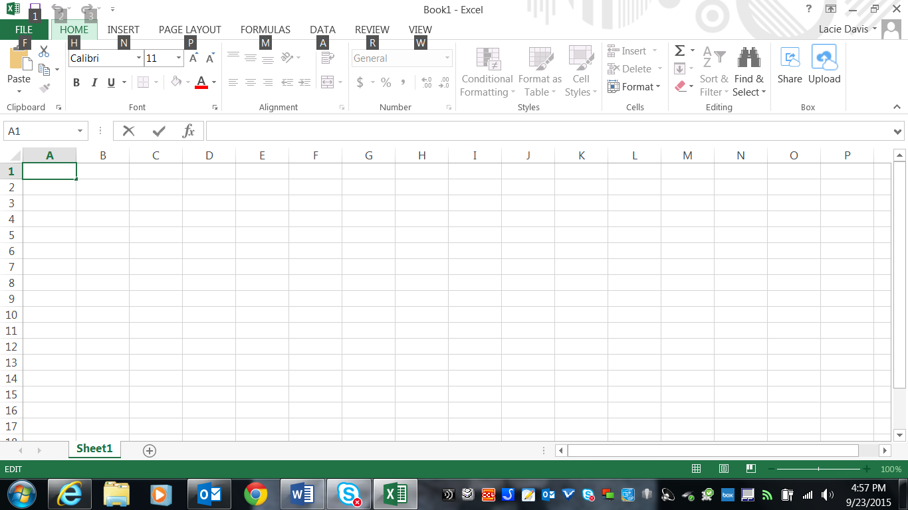

Formula Bar

When entering dates, Excel defaults to the current year if the year portion of the date is not entered.
You may edit cell contents from the Formula bar, or from directly inside the cell. To edit from the Formula Bar, select the cell and click inside the Formula Bar. When done typing, either press the Enter key or click inside another cell. To edit directly inside a cell, either double click inside the cell, or select the cell and press the F2 key.

How do I move and/or copy cells?
To move cell contents, right-click in the selected cell and click Cut. To copy cell contents, click Copy. Then right-click in the new location and click Paste. To paste a group of cells, right-click in the cell where the top left cell of the group should be located, and click Paste. Remove the animated border around the original cell by pressing the ESC key, or start typing in a new cell.
How do I add and delete rows and columns?
To insert a new row in a spreadsheet, right-click on a row number, and click Insert. Excel always inserts the row ABOVE the row that was clicked on. To delete a row, right-click on the row number, and click Delete.
To insert a new column, right-click on a column letter and click Insert. Excel always inserts the column to the LEFT of the column that was clicked on. To delete a column, right-click on the column letter, and click Delete.
How do I set a print area?
Step 1: Open the spreadsheet that contains the cells that you want to select and print.
Step 2: Use your mouse to select the cells that you want to print.
Step 3: Click the Page Layout tab at the top of the window.
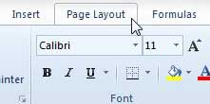
Step 4: Click the Print Area drop-down menu in the Page Setup or (Page Layout) section of the ribbon at the top of the window, then click the Set Print Area option.
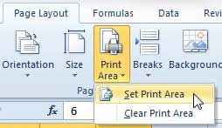
Now when you go to print the document, you should only be printing the area that you just selected. To undo this setting and clear the print area, simply return to the Print Area drop-down menu in Step 4, then click the Clear Print Area option.

How do I save the document?
SAVE OFTEN!!! YOU DON’T WANT TO LOSE ALL YOUR HARD WORK!
Step 1: Create or open your file. If this is a new file you’ve just created and are saving it for the first time, proceed to Step 2. If you’re re-saving an existing Excel document, navigate to its location on your computer and open it.

Step 2: Launch the save file window. With your Excel file open, click “File” from the menu in the top left-hand corner of Excel. Then click “Save As.” If you’re using a Windows computer, you can also launch the Save File window by pressing the "Control" key and then the “S” key on your keyboard.

Step 3: Type the name of your file into the box beside the words “Save As” at the top of the Save File window.

Step 4: Navigate to the Desktop folder in the Save File window. It is often located in the “Computer” section.

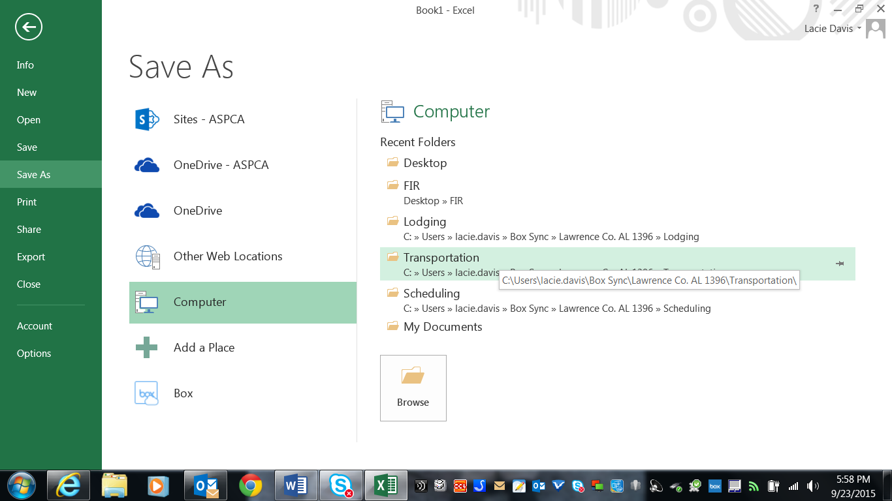

Below the box where you’ve entered the name of your file, you’ll see a series of folders, each of which represents a location on your computer. Click through the folders until you locate the one labeled “Desktop”.

Step 5: Click the “Save” button in the bottom right-hand corner of the Save File window.

How do I sort data?

- Click on the column you want to sort.
- Click on the Data tab. Then, click Sort.
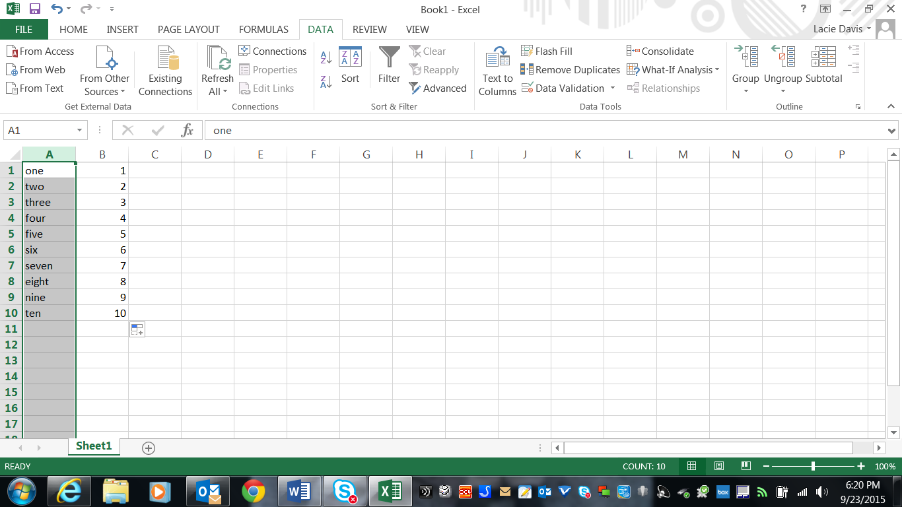

This box will appear. The “expand the selection” box is checked. Click the Sort button.

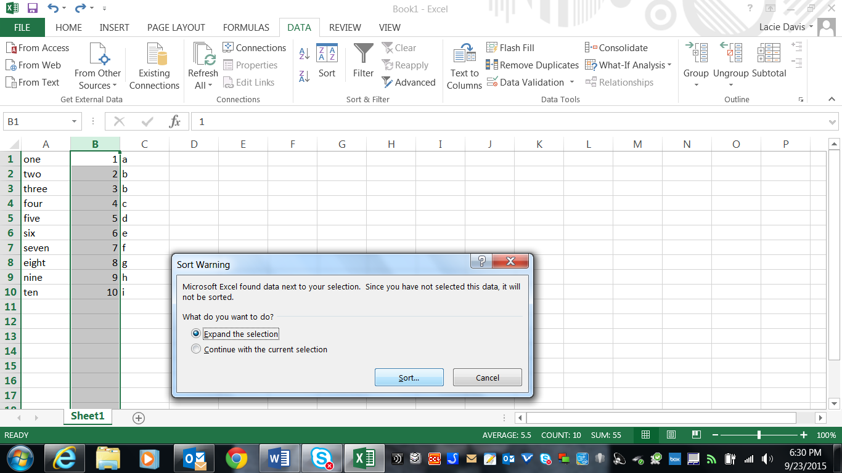

This box will then appear. Click on the “Sort by” drop down to choose how you want to sort. Click “Ok.”
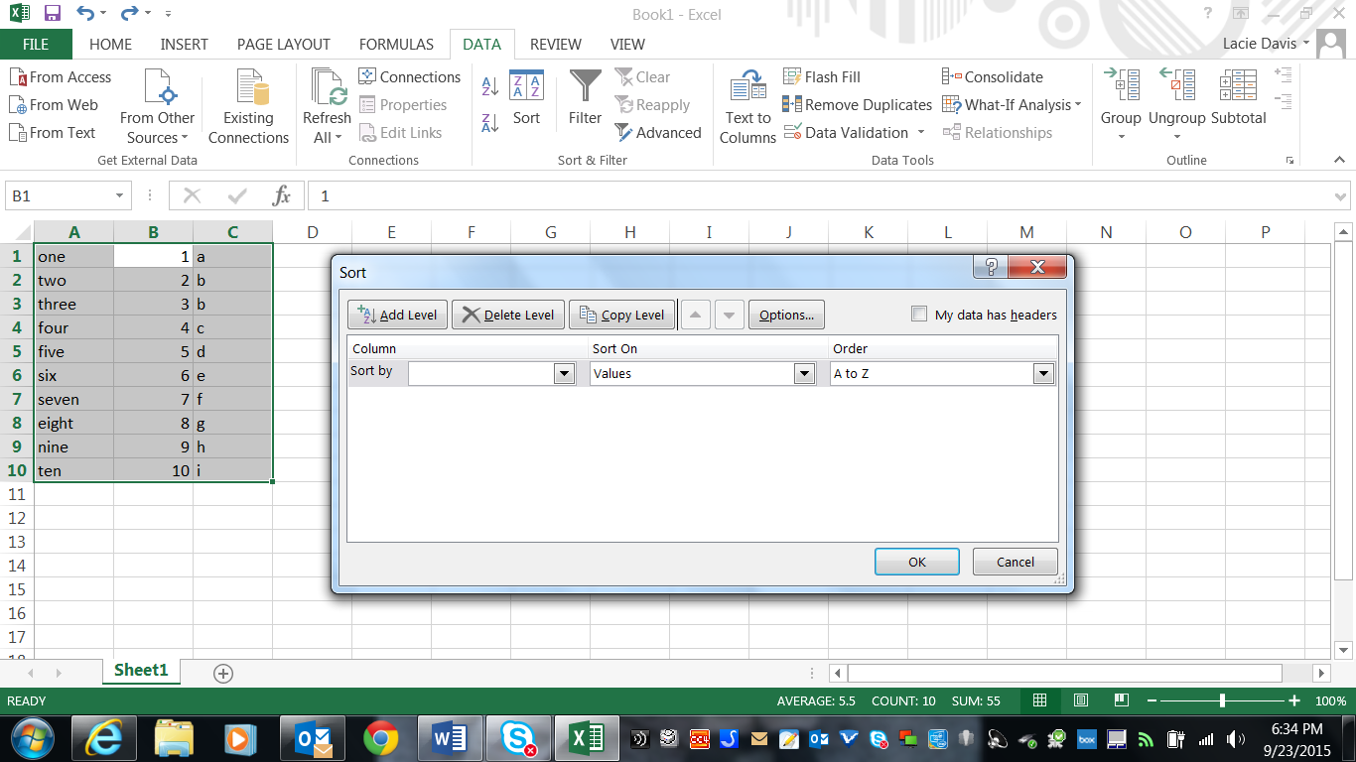

How to find an address or other searchable item?

You can use Excel's Find and Replace feature to quickly find specific items. You can use Excel's Go To Special feature to quickly select all cells with formulas, comments, conditional formatting, constants, data validation, etc.

Find
To quickly find specific text, execute the following steps.
1. On the Home tab, click Find & Select, Find...
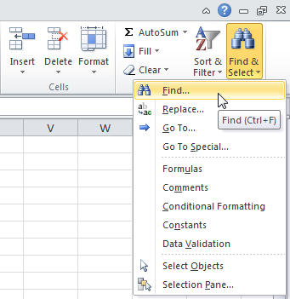
The 'Find and Replace' dialog box appears.
2. Type the text you want to find. For example, type Ferrari.
3. Click 'Find Next'.
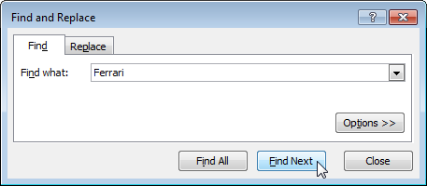
Excel selects the first occurrence.
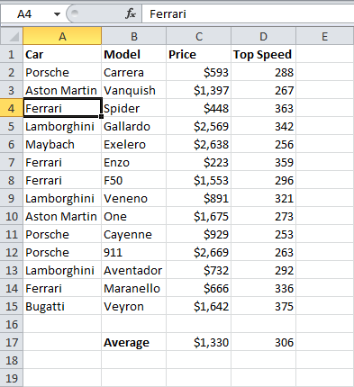
4. Click 'Find Next' to select the second occurrence.
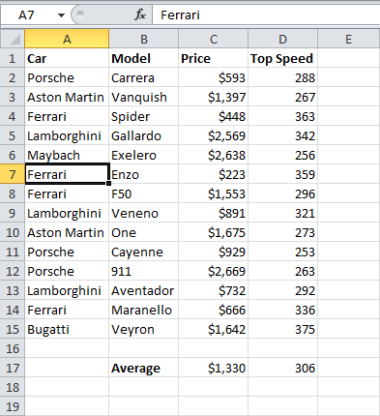
5. To get a list of all the occurrences, click 'Find All'.
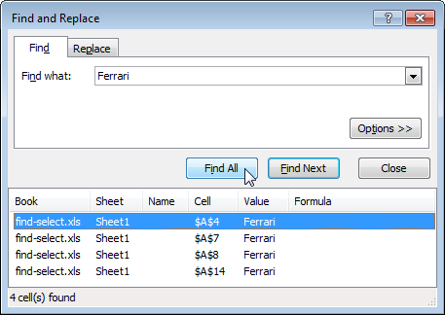

Column Key
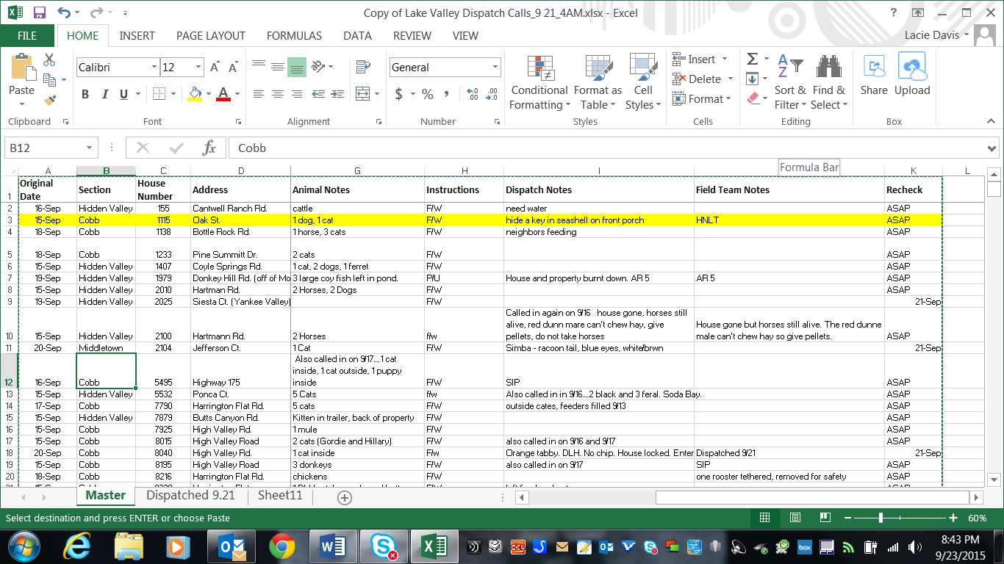
If a recheck or refeed, etc. is required, the date it should happen goes here
Notes from the field team from their end of day reports
Information given by caller regarding the location, etc.
House numerical
Date the call was taken
What to do: feed and water, pick up, etc.
Notes on the animal (type, #, etc.)
Address
Section of the County

